**EXPERIMENT: 6**

Student name:- Aditya choudhary

Roll no:- 18csu011

Semester:- 5th

Section:- A

Date:- 08 September 2020

**Aim:-** Write a program for SJF(Shortest Job First) with pre-emptive.

**Some Concept SJF with Pre-emptive:**

* In Pre-emptive SJF scheduling, jobs are put into the ready queue as they come. A process with shortest burst time begins execution.
* If a process with even a shorter burst time arrives, the current process is removed or pre-empted from execution, and the shorter job is allocated CPU cycle.

Code SJF with Preemptive:

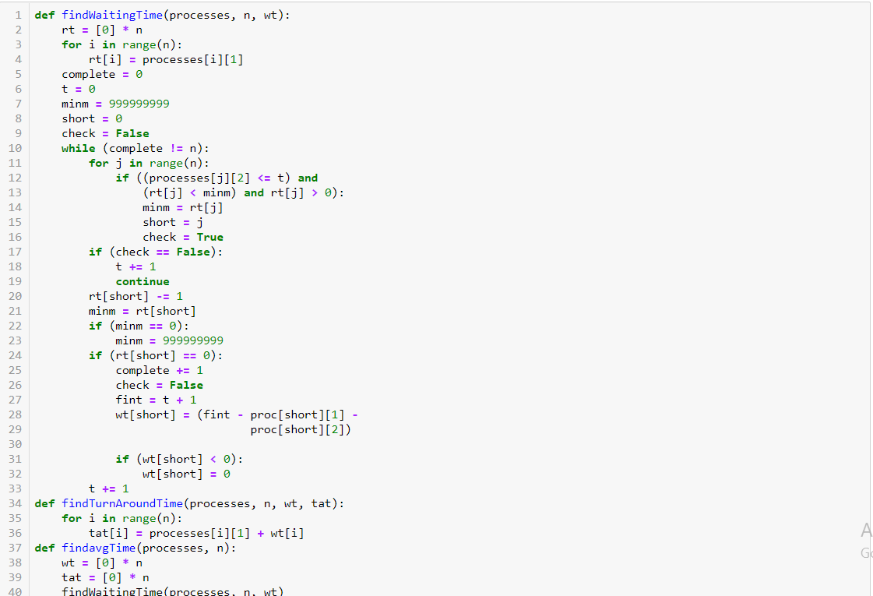

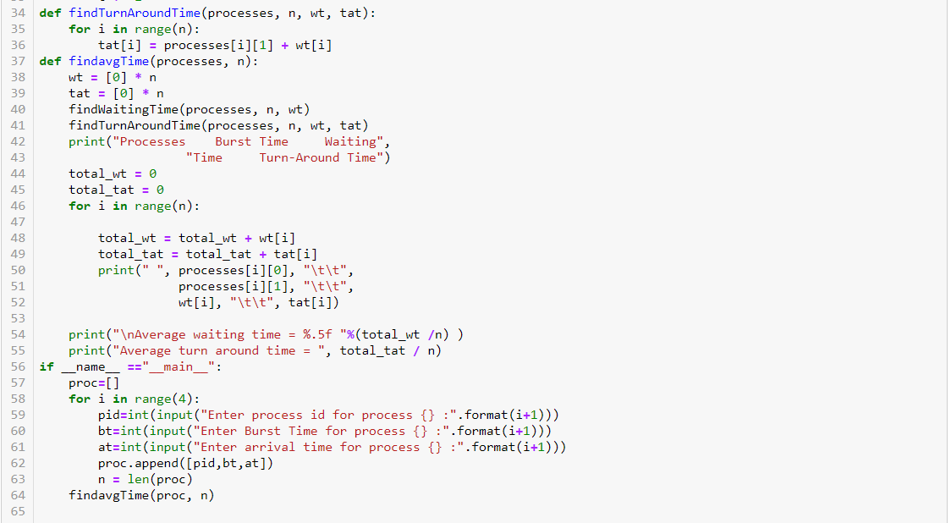

**OUTPUT:-**

